Issued on behalf of Northern Ireland Local Government Association

# PRESS RELEASE

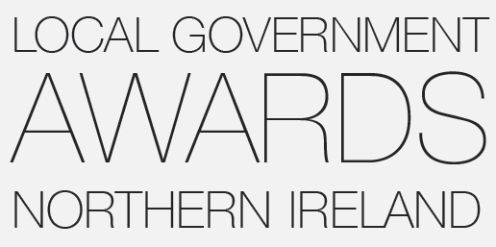

**4th July 2019**

LOCAL GOVERNMENT AWARDS NORTHERN IRELAND

*NOW OPEN FOR ENTRIES*

RECOGNISING COMMUNITY IMPACT & SERVICE EXCELLENCE IN COUNCILS

**The Local Government Awards Northern Ireland showcase brilliance in service provision, new initiatives and untiring commitment from council officers, councillors and our partners. The Awards offer public recognition whilst giving inspiration & learning to peers who deliver front line and other key local government services. The Award categories are designed to foster innovation, exceptional commitment and great work, while also providing opportunities for local government staff and members to step forward and shine.**

**Councillor Frances Burton, NILGA President, said:**

“As we enter a new 4-year electoral term, it’s important to recognise the dramatic changes that have taken place in local government over the past number of years. A massive amount of hard work and dedication has gone into modernising and improving councils to benefit local people and local communities – as well as wider government, the economy and civic society. This work continues despite no Legislative Assembly. We must continue to be innovative, ambitious and citizen focused, despite increasing pressures and the current uncertainties.

“The Awards also offer great learning platform and information exchange, something NILGA fosters every day through our Elected Member Development & Officer policy guidance & training work. I would encourage those working within the local government sector to put forward their nominations as soon as possible, to participate and possibly be recognised for their outstanding contribution,” said Frances.

**Paul O'Brien, Chief Executive, Association for Public Service Excellence (APSE), said:**

“The Northern Ireland Local Government Awards showcase the remarkable work of local councils in Northern Ireland. It is vitally important that we recognise the strength of local government in working with all communities to deliver excellence and innovation in local government services. Each year the award submissions highlight just how committed local councils are to delivering for local people and local economies.”

The Awards cover nine categories and sponsor partners / support bodies contributing are: Association for Public Service Excellence (APSE); William Johnston Memorial Trust (WJMT); Enterprise Northern Ireland; Society of Local Authority Chief Executives and Senior Managers (SOLACE); Northern Ireland Local Government Association (NILGA); National Association of Councillors (NAC); Sustainable NI; Mineral Products Association NI (MPANI) and Tourism NI.

Nominees are judged by an independent panel. With finalists in each category getting an opportunity to go forward to the Awards Recognition Evening as the culmination of NILGA’s Flagship Annual Conference, at the Crown Plaza Hotel, Belfast, on Thursday 20th February 2020.

Entry forms are available to download from the NILGA or APSE websites – [www.nilga.org](http://www.nilga.org/Local-Government-Awards-2017.aspx) or [www.apse.org.uk](http://www.apse.org.uk/apse/index.cfm/news/2017/local-government-awards-northern-ireland-now-open-for-entries/) **The deadline for completed applications is 16th September 2019.**

ENDS

**NOTES TO EDITOR:**

**Photo caption**

Pictured at the launch of the 2020 Local Government Awards Northern Ireland in Newcastle, Co Down are l-r - Michael McQuillan (Enterprise NI), Emma Adair (Sustainable NI), Derek McCallan (NILGA), Owen O’Connor (William Johnston Memorial Trust), Ald Michael Henderson (National Association of Councillors), Cllr Terry Andrews (Association for Public Service Excellence) and Gordon Best (Mineral Products Association NI).

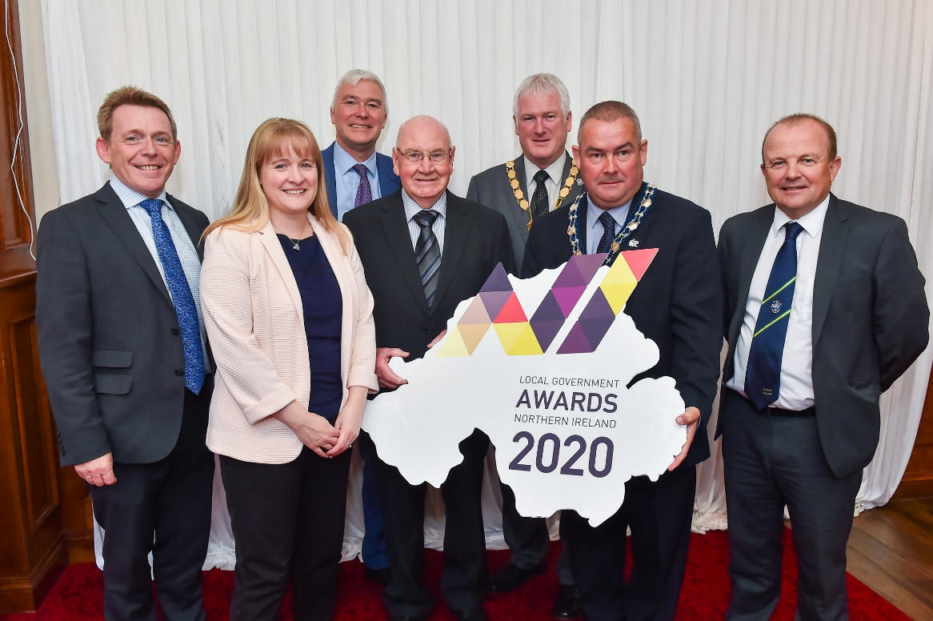

**The 9 award categories are:**

* 1. Best Local Authority Service Team (APSE)
  2. Employee of The Year (WJMT)
  3. Best Enterprise Initiative by a Council (Enterprise NI)
  4. Best Local Authority Community Planning Initiative (SOLACE NI)
  5. Best Local Authority Elected Member Development Initiative (NILGA)
  6. Best Initiative by a Councillor/Councillor Group (NAC)
  7. Best Local Authority Tourism Initiative (Tourism NI)
  8. Excellence in Environmental Sustainability by a Local Authority (Sustainable NI)
  9. Best Local Authority Design & Build Capital Project (MPANI)

**The supporting bodies who are contributing financially and administratively are:**

* + 1. Association for Public Service Excellence (APSE);
    2. William Johnston Memorial Trust (WJMT);
    3. Enterprise Northern Ireland;
    4. Society of Local Authority Chief Executives and Senior Managers (SOLACE);
    5. Northern Ireland Local Government Association (NILGA);
    6. National Association of Councillors (NAC)
    7. Tourism NI
    8. Sustainable NI
    9. Mineral Products Association NI (MPANI)

**More information: Mark Maher, NILGA, Tel. 028 9079 8972 Email:** [**m.maher@nilga.org**](mailto:m.maher@nilga.org)

*Disclaimer: The Northern Ireland Local Government Association (NILGA) endeavours to ensure that the information contained within our*

*Website, Policies and other communications is up to date and correct. We do not, however, make any representation that the information*

*will be accurate, current, complete, uninterrupted or error free or that any information or other material accessible from or related to*

*NILGA is free of viruses or other harmful components. NILGA accepts no responsibility for any erroneous information placed by or on*

*behalf of any user or any loss by any person or user resulting from such information.*