APSE Catering Advisory Group

**Friday 14 June 2019**

**The Van Coulter Suite, APSE, Old Trafford, Manchester**

Dear Colleagues,

I am delighted to invite you to join us in for the APSE catering advisory group which will be held on **Friday 14 June 2019.**

This is a **FREE** event for all members and officers of councils in APSE membership and if you are in receipt of this e-mail, your council is in APSE membership.

[**Please click here to book online**](https://www.surveymonkey.co.uk/r/Y2QGSNT)

**Speakers and topics include:**

**Start time: 10am for Coffee and Registration for a 10.30am start.**

1. **Welcome from the Chair of the Group**.
2. **10 Years of Food for Life Served Here**

* 2009 – 2019 successes and challenges
* Impact of Food for Life Served Here
* What next – short and long-term priorities

**Speaker**: Caren Longden, National Development Manager Food for Life Served Here, Soil Association

1. **The Journey to insourcing a catering service.**

* A background to the catering service at Oxfordshire
* The challenges of bringing the service back in house
* The current position and the future strategy

**Speaker**: Gail Witchell, Principal Officer, Oxfordshire County Council

1. **Catering: Developing a future programme**

* Past, current and future
* Review of the APSE State of the Market Survey
* New initiatives in the sector
* FM, Catering and Building Cleaning Seminar

**Speaker**: Vickie Hacking, Principal Advisor, APSE

1. **National APSE update on the latest policy issues; lobbying activity; briefing papers and publications.**

**Ends: 12.30pm – networking and lunch**

Kindest regards



Vickie Hacking,

Principal Advisor, Association for Public Service Excellence

On behalf of Cllr Julie Simpson, Chair of the APSE catering advisory group



**APSE Office Map**

**Association for Public Service Excellence**

**3rd Floor, Trafford House**

**Chester Road**

**Manchester**

**M32 0RS**

**Tel: 0161 772 1810**

****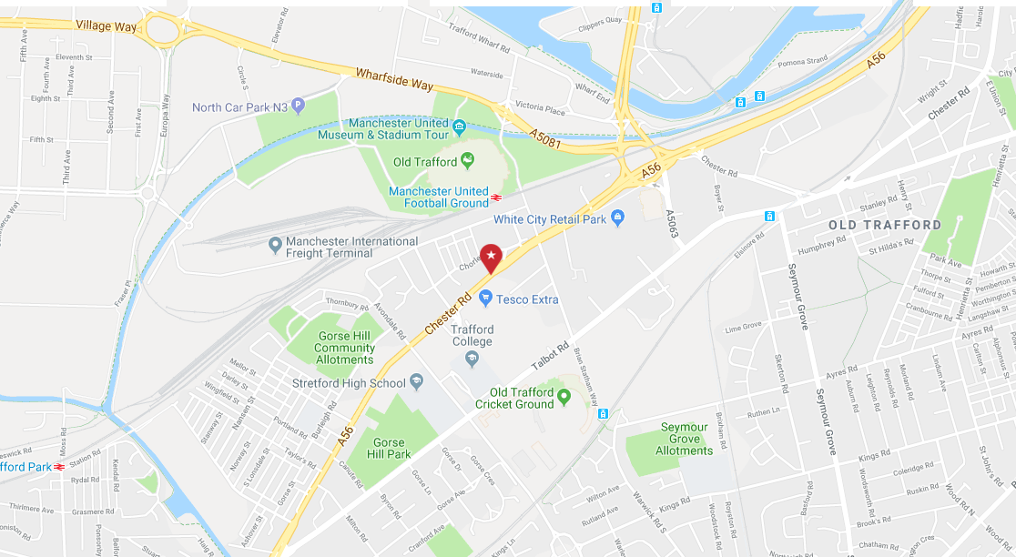

D

C

B

A

**BY ROAD**

**From the North:**

M6, then M61 (signposted Manchester) to junction with M60 Ring road.

Join M60 at junction 15 following signs for M60 Ring road (West & South)/Trafford Park

Along M60 to junction 12. Exit following signs for M602 Salford. M602 to junction 3. Exit following signs for A5063 Salford Quays/Trafford Park.

**From M602** Take the A5063, a dual carriageway road with local signs for Manchester United. Keep going straight ahead on this road and after ¾ mile, immediately after crossing the Manchester Ship Canal Bridge, the road swings left to the White City Circle junction (signposted A5063 Manchester). Turn right at the junction, following signs for Manchester United Football Stadium. Keep straight ahead on White City Way to merge onto Chester Road. Trafford House is located 0.5 mile ahead on the right., opposite the Tesco superstore.

**From North East, West Yorkshire** Join the M62 and proceed to junction 18. Keep straight ahead, the motorway changes at this point to become the M60 Ring road (North). Stay on M60 Ring Road following signs for M60 Ring road (West & South) & Trafford Park Exit M60 at junction 12 following signs for M602 Salford. Along M602 to junction 3. Exit following signs for A5063 Salford Quays/Trafford Park. Follow directions from M602 shown in paragraph above

**From the West** Join the M62 following signs for Manchester and proceed to the junction with the M602. Keep straight ahead to join M602 following signs for M602 Salford. Along M602 and exit at junction 3. Follow signs for A5063 Salford Quays/Trafford Park. Follow directions from M602 shown in paragraph above.

**From the South** Join the M6 to junction 19 at Knutsford. Exit onto A556 (just after Knutsford services-signposted Manchester). Keep on the A556 following signs the M56/Manchester. Join M56 at junction 7 (signposted Manchester). At the end of the M56, the road becomes a dual-carriageway road (the A5103). Keep straight ahead for ½ mile approx, and then join left-hand lane to join M60 Ring road (follow signs for Stretford). Along M60 Ring road (South) to junction 7, and then exit following signs for A56 Stretford. Join dual-carriageway A56 Chester Road following signs for Stretford & Manchester. There are local signs on this road for Manchester United. After 1.3 miles the A56 forks. Move to the right-hand lane to join the A5067 Talbot Road (there is a local sign for Old Trafford Football Ground just before the junction). Trafford House, is on Chester Road, 1 mile ahead on the left.

**From Manchester Piccadilly Train Station / Victoria Train Station, Manchester City Centre:**

From the station you can take a taxi which will take approx. 15 – 20 minutes.

*or*

From the station catch the Metrolink going to Altrincham, depart at the Old Trafford stop, this will take approximately 15 minutes. As you walk out the station, walk straight ahead towards Manchester United Football Ground, turn left in front of the stadium and Trafford house is on the right hand side. This will take approximately 5- 10 minutes.

**Public Transport**

Trafford hosts two major sports grounds and is therefore well served by Public Transport links. Trafford House is accessible by the Metrolink connections from Manchester City Centre and local bus routes.

From Manchester Piccadilly Train Station / Victoria Train Station catch the Metrolink going to Altrincham, depart at the Old Trafford stop, this journey will take approximately 15 minutes. As you walk out the Metrolink Tram station, walk straight ahead towards Manchester United Football Ground, along Warwick Road, then turn left onto Chester Road, you will see Manchester United Stadium. Turn left in front of the stadium. You will pass a Halfords store, A Sixt Car Rental and a Kwik Fit store. Trafford house is on the right hand side just slightly further along the road opposite the Tesco Superstore. The walk from the Metrolink Tram station will take approximately 5- 10 minutes.

Bus routes and details are below but please check with Transport for Greater Manchester (website)

Taxi

Victoria and Piccadilly Stations both have ample taxi services and a taxi journey to Trafford House will take around 15 minutes.

**Bus Stops within 100m from Trafford House**

Bus stop SJ0019 (turn left outside the front entrance) to go toward Manchester and SJ0038 (across the road outside Tesco) to go toward Stretford.

**Stage Coach:**

Bus 69: Traveling to Stretford – Ordsall – Pendleton – Eccles

Bus 255: Traveling to Partington – Urmston – Stretford – Manchester Piccadilly

Bus 256: Traveling to Flixton – Stretford – Hulme – Manchester

Bus X50: Travelling to Manchester Piccadilly – Trafford Centre

**Arriva:**

Bus 263: Traveling to Altringham – Sale – Hulme – Manchester

Bus 264: Traveling Altringham – Sale – Stretford – Manchester

Visit <https://www.tfgm.com/> or call Traveline on 01612441000 for more details and timetables.

**Tram**

The closest Tram station is Old Trafford Station located 10 min walk from Trafford House.

When leaving the station follow Warwick Road then turn left onto Chester Road. Trafford House will be located on your right hand side.

**Car Parking Facilities**

(Map Ref A) Delegates can use the parking facilities at the Lancashire County Cricket Club, Talbot Rd, Stretford M16 0PX which operates a pay on departure system. Delegates can park for £4.40 for 4 hours. From the car park it is a 5 minute walk to Trafford House.

(Map Ref B) There is pay and display car parking available at Old Trafford tram stop, M16 9AL.

(Map Ref C) Parking is also available opposite the APSE office at Tesco Extra for Tesco Customers. Please note there is a 3 hour parking limit and any visitors parking at Tesco do so at their own risk.

(Map Ref D) There is limited pay and display on street parking on Chorley Street, to the rear of Trafford House (M32 0RL), charged at up to £5 for 4 hours. Payment is by cash or by a mobile phone pay system. Please disregards the signage that states Trafford House Approved Parking. This is restricted private parking and not available to visitors. Please note surrounding areas are residential and subject to a permit system

**APSE Catering Advisory Group**

**Friday 14 June 2019**

Please ensure that you confirm your attendance or apologies for the meeting by posting or emailing this booking form to before **Monday 10 June 2019**

**Authority**: ……………………………………………………………………………………………………

**Address** …………………………………………………………………………………………………………

………………………………………………………. ……………

**Postcode**

…………………………………

|  |  |  |  |
| --- | --- | --- | --- |
| **Name** | **Email** | **To attend Advisory Group** | **Apologies for Advisory Group** |
|  |  | □ | □ |
|  |  | □ | □ |
|  |  | □ | □ |

**In order to process this booking, please give permission for APSE to store your contact details.**

** Yes I agree**

*\*Our GDPR Policy:*

*We will hold your details on the APSE database until you tell us you wish to be removed. We will action all requests for changes to your details as soon as possible but we will not take longer than 30 days.*

*We will not sell or pass on your details for commercial gain to any third party.*

*We may need to pass your name and organisation details to some third parties. Examples include hotels or other accommodation providers if you book a residential seminar or training event, a mailing house so you can receive APSE research, APSE’s member magazine or other member information, or provide details to venues for health and safety purposes or for reasonable purpose to ensure we continue to provide a service to our member authority contacts like you. We will include delegate names and their organisation in seminar delegate packs, training packs, and performance reports, and network queries or other service based information. As APSE is a networking organisation this will help all our members make the most of the network. You will need to specifically ask us not to do this if you object to your inclusion.*